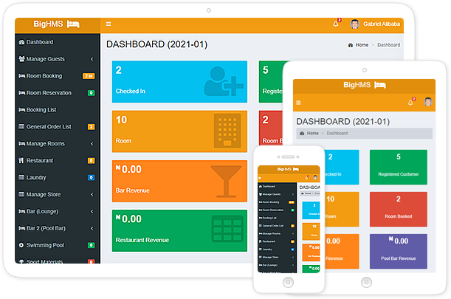
BIGHMS
(Hotel Management System With Door-Lock System)
Table of Content
- Introduction on BigHMS
- BigHMS Features, Modules & Their Functionalities
- Types of BigHMS Setup
- Pricing
- How to Install BigHMS
  - Installation of XAMPP
  - BigHMS Files and Mysql Database
  - How to Login from Client PC
  - How to Login from Server PC
  - Installation of Door-lock Smartcard Software (DLSS)
  - Configuration of MySQL Privilege For DLSS
- How to Connect Remotely to BigHMS Database Server
BIGHMS.COM
INTRODUCTION:
BigHMS is a hotel management system that comes with hotel door-lock software. This software will enable you to manage every aspect of your hotel starting from installation and configuration of hotel door-locks, generating door-lock card for each hotel doors, check-in and check-out of guest from hotel, writing new door-lock card for customer, managing bar(s), restaurant, spa, laundry, swimming pool, cab. It will helps you generate comprehensive sales bighmsreports, etc.

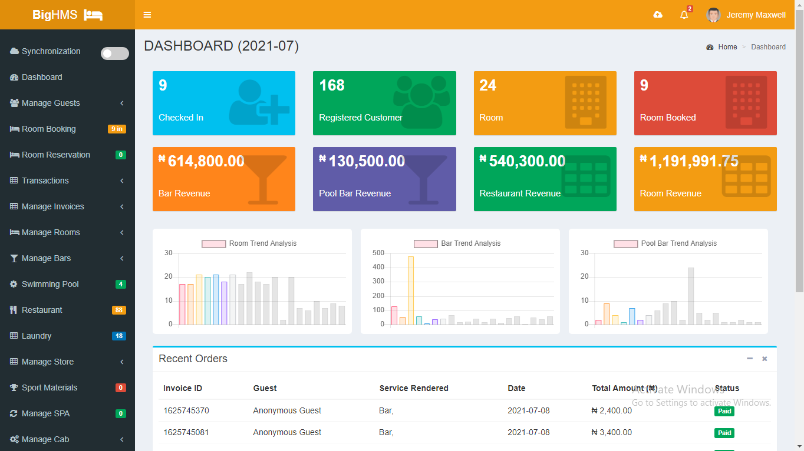

MODULES & THEIR FUNCTIONALITIES:
It comprises of so many features/modules to manage your hotel, they are;
- Reception Modules:
  - Manage Guest: Registration of Guest, Companies, and Creation of Wallet
  - Room Booking: Checking in and out of Guest
  - Room Smart Card: Generating Room Smart Card for your guest with our built-in encoding software. Note: Only work with RFID, for other types of smart doors, Contact us on whatsapp +2347060624802
  - Room Reservation: Reserving room for Guest(s)
  - Expenditure: Manage expenses
- Bar Modules:
  - Bar POS System: POS system to sell drinks, manage transactions, and print receipts for customers.
  - Waiter/Waitress Tablet: Tablet app for waiters/waitresses to place customers’ orders.
  - Swimming Pool:
  - Generate Daily Report
- Restaurant Modules:
  - Restaurant POS System: POS system to sell food, manage transactions, and print receipts for customers.
  - Generate Daily Report
- Other Modules:
  - Laundry Module: To render laundry service.
  - SPA Module: To render SPA service.
  - Sport Module: To sell sport materials.
  - Manage Cab: To register cab for clients, and manage their cab history
  - Manage Gym: To register members for gym and manage their subscription
  - Bar Request: To manage requests from bar
  - Trend Analysis: To show trend of sales in a graphical form. This lets you know which services/products clients order frequently.
  - Manage Staff: To create and manage staff accounts.
  - Service category: To configure/compute the category of room, food, and drink.
  - Settings: To configure general app setting, Restaurant/Bar Table Numbering, Backing Up Database.
  - Comprehensive Reports: This module lets you generate general (bar, restaurant, room, etc.) reports, Stock Report, Hotel-door Master Card Log History, SSS Report, etc.

TYPES OF BIGHMS SETUP:
We have two main types of setting up bighms;
- Single-System Setup: This is setting up the whole application on a single system. It can be laptop or desktop PC.
- Clients-Server Setup: This is connecting many PCs to your hotel PC Server to run the application. That is; the bighms is installed on your PC Server, and Receptionist, Bar, Restaurant PCs, etc. are connected to the server to run the application.
FEATURES & PRICING
Features:
- Customer Management System
- e-Wallet System
- Room Booking & Management System
- Room Reservation System
- Transaction & Invoice Management
- Company Management System
- Bar Management System (Up-to 3 Bars) with POS System
- Restaurant Management System with POS System
- Swimming Pool, Laundry, SPA, Cab, Gym Sales Management System
- Reports Management System
- Store Management
- Expenditure
- Product Trend Analyzer
- Staff Management
- Door-lock Control System (RFID, ORBITA...etc.)
- Log History, Table Numbering, and Backup Manager

PRICING:
PLANS | FEATURES | PRICE
Plan A | All Features with Door Lock Management System. | 650,000
Plan B | All Features without Door Lock Management System. | 500,000
Plan C | Includes Only 1 Bar, Restaurant, Room Book and other related features, excluding Swimming Pool, Laundry, SPA, Cab, and Gym Management System. It includes Door lock Management System. | 550,000
Plan D | Includes Only 1 Bar, Restaurant, Room Book and other related features, excluding Swimming Pool, Laundry, SPA, Cab, and Gym Management System, and No Door lock Management System. | 450,000
Plan E | Just 1 Bar Management System and related features, with reports, staff, expenditure, trend analyzer store management system, excluding other unrelated features. | 350,000
Plan F | Just Room Booking Management System and related features, with reports, staff, expenditure, excluding other unrelated features. | 350,000
Plan G | Just Restaurant Management System with related features, and reports, staff, expenditure, trend analyzer store management system, and excluding other unrelated features. | 350,000

INSTALLATION OF BIGHMS
INSTALLATION OF XAMPP
First download XAMPP for PHP 5.6 https://www.apachefriends.org/download.html and install it on your system (or server)

BIGHMS FILES AND MYSQL DATABASE
Unzip and Copy BigHMS Folder into htdocs of XAMPP. If you install xampp to c: drive, the path should be c:\xampp\htdocs. Make sure the folder name is bighms. If you use rename the folder, note it because you will include it in config file later.
Now, to setup database for bighms;
- Open browser, and type http://localhost/phpmyadmin/
- Click databases tab
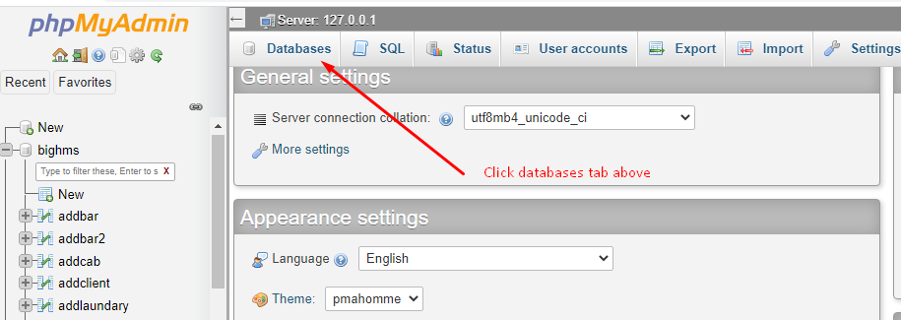
- Type in bighms and click create button 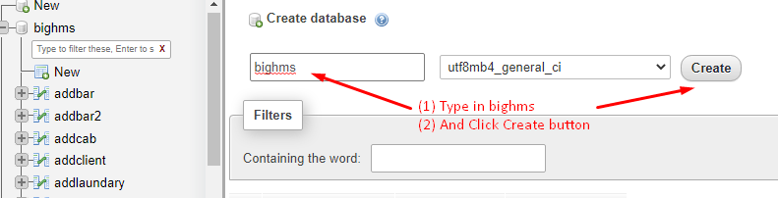
- Then click bighms to open it. 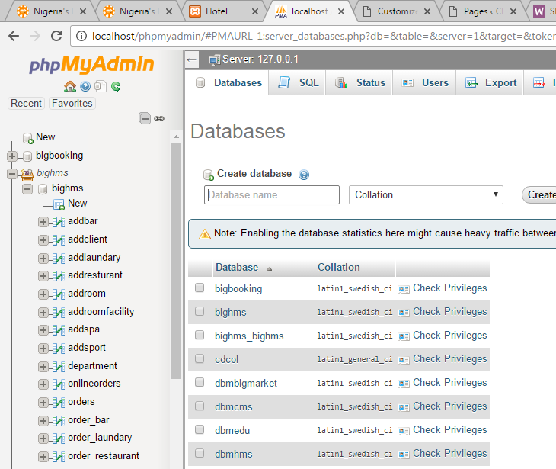
- Click “Import” tab 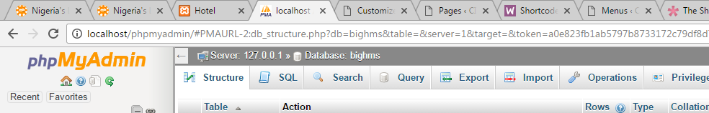
- Click “Choose File” button to location database in the zip file sent to you. The database file is inside the database folder in bighms folder. Note: c:\xampp\bighms\database\ 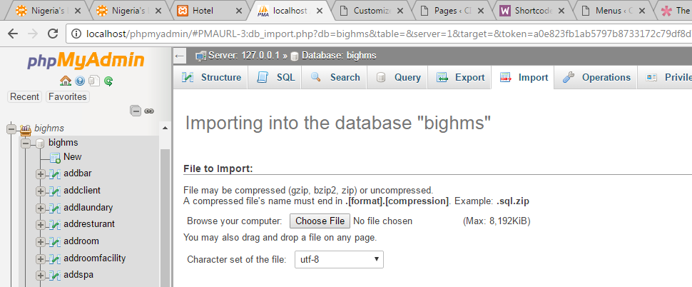
- Then click “GO” button below to import
- Finally, browse http://localhost/bighms to access the application from the same system (say server).

To access the application from another system (say client):
Make sure you assign IP ADDRESS to the server. Example say SERVER IP ADDRESS is 198.163.1.26.
- On Server, open config file in root folder of bighms.
- Change the $domain IP Address to your own IP address. i.e. 198.163.1.26 and save the file
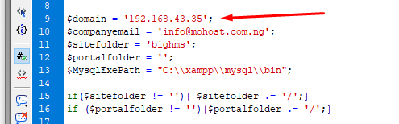
- If you change foot folder of the application from bighms to something else, make sure you include it in $sitefolder variable. After making changes, save the file
- Now, go to your system (client system), open your browser and type http://your-Ip-Address/bighms example: http://198.163.1.26/bighms

How to Login on Client PC
- Type http://your-Ip-Address/bighms example: http://198.163.1.26/bighms
- Enter your username and password. E.g. username: admin, password: 111, you can login as receptionist, manager, bar, etc. collect your login details from your administrator.

How to Login on Server PC
- Type http://localhost/bighms
- Enter your username and password. E.g. username: admin, password: 111, you can login as receptionist, manager, bar, etc. collect your login details from your administrator.

Installation of Hotel Door-lock & Door-Lock Smartcard Software
We specialize in the installation of Hotel Door-Locks and setting up the USB encoder to manage your hotel doors. Also, BigHMS has customized door-lock Smartcard Software which let you manage the creating of guest card, master card, and building card. With this software coupled with BigHMS, you can monitor how many times cards been generated. See diagram below;

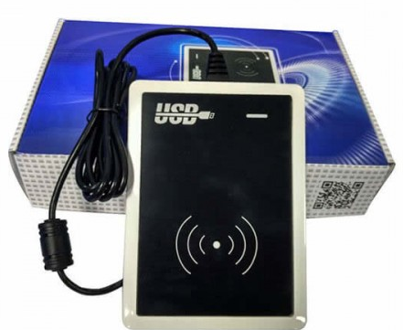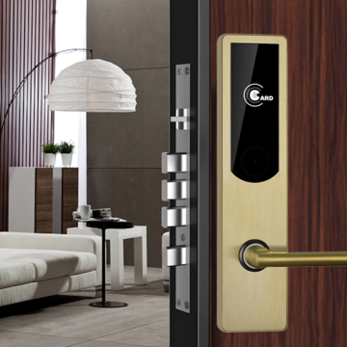

For more information or help call our HOTLINES
T: +234-7060624802, +234-703-909-0014, +234-8119996059
E: favoursdot@gmail.com, support@progmatech.com
W: www.progmatech.com

